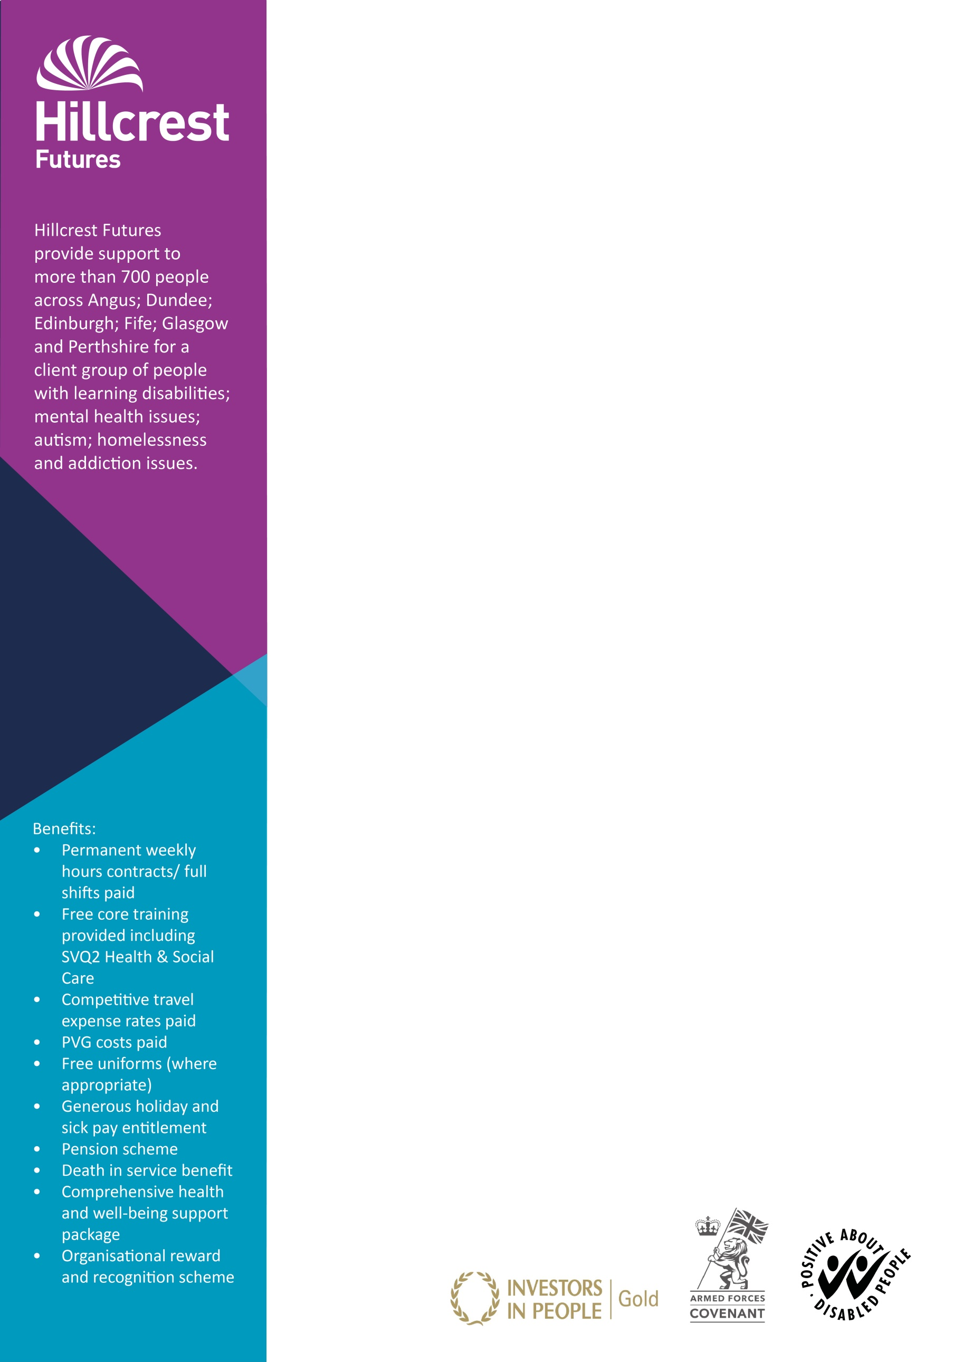

**The Service**

Portman Street is a 24 hours per day, 7 days a week, emergency supported accommodation based in Glasgow’s south side for 30 men who are homeless. We are a registered housing support service.

Service users have a wide variety of support needs including, but not limited to, mental health issues, substance misuse and learning disabilities.

**The job**

The role of the Night worker will act as first point of contact to service users, members of the public, and emergency service’s whilst on night shift. The night shift worker will have responsibility for the safety and security of the building and service users that reside in the service.

Due to the complex nature of the client group the role will consist of crisis intervention.

**The Candidate**

You should be confident in dealing with a homeless client group and have compassion and understanding for the issues homeless people face. You should have willingness to undertake any training requirements relevant to this post.

All successful candidates will be required to obtain registration with the Scottish Social Services Council (SSSC) within 6 months of taking up the post.

**Application process**

Please apply online: [Hillcrest Futures Jobs](https://careers.hillcrest.org.uk/hillcrest/search/results/feedid-5157_futuredays-0_-all_field7670-2/1)

**Please note we do not accept C.V’s or approaches from recruitment agencies.**

We promote equality through seeking to eliminate unlawful and unfair forms of discrimination, as appropriate.

Hillcrest Futures Ltd is a registered Charity No. SC034261

Job reference: HH19/112  
Post: Concierge, Nightworker  
Location: Portman Street, Glasgow

Hours per week: Various hours up to 39 are available  
Rate of pay: £18,252 pro rata per annum, £9.00 per hour  
Contract terms: Permanent

Closing date: 24th July 2019

*V3Jul2019*