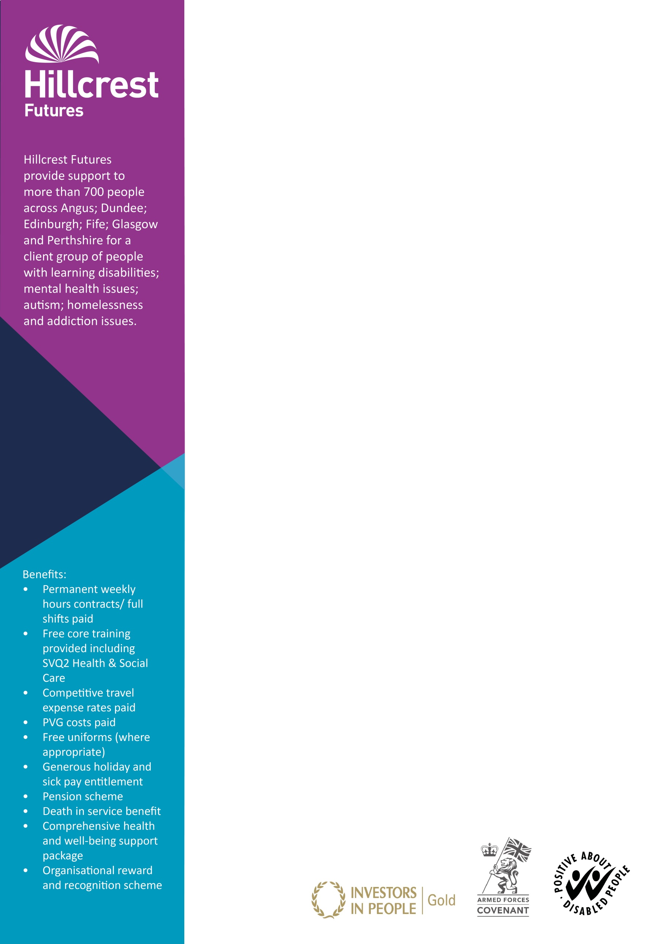

**The service**

Our Dunfermline Service provides housing support and care at home to adults across West Fife on an outreach basis. We support individuals with wide ranging support needs, including learning disability, autism, mental health and complex needs.

**The job**

You will provide active support to enable individuals to achieve and manage their health and social care needs through a holistic and person centred approach.

**The candidate**

We would be keen to hear from you if you are:

* Positive, flexible and committed to making a difference
* Have or are willing to undertake an SVQ2 award
* Willing and able to work shifts, including sleepovers and weekend working
* Have a driving licence and use of your own car

**Application process**

Applications can be made through our website:

[www.](http://www.)hillcrestfutures.org.uk

**Please note we do not accept C.V’s or approaches from recruitment agencies.**

We promote equality through seeking to eliminate unlawful and unfair forms of discrimination, as appropriate.

Hillcrest Futures Ltd is a registered Charity No. SC034261

*V3Jul2019*

Job ref: HH19/127   
Post: Support Workers (Female)   
Location: Dunfermline (Outreach Service)

Hours per week: Various part time and full time positions

Rate of pay: £18, 252 per annum (£9.00 per hour)

Contract terms: Permanent

Closing date: Friday, 26th July 2019