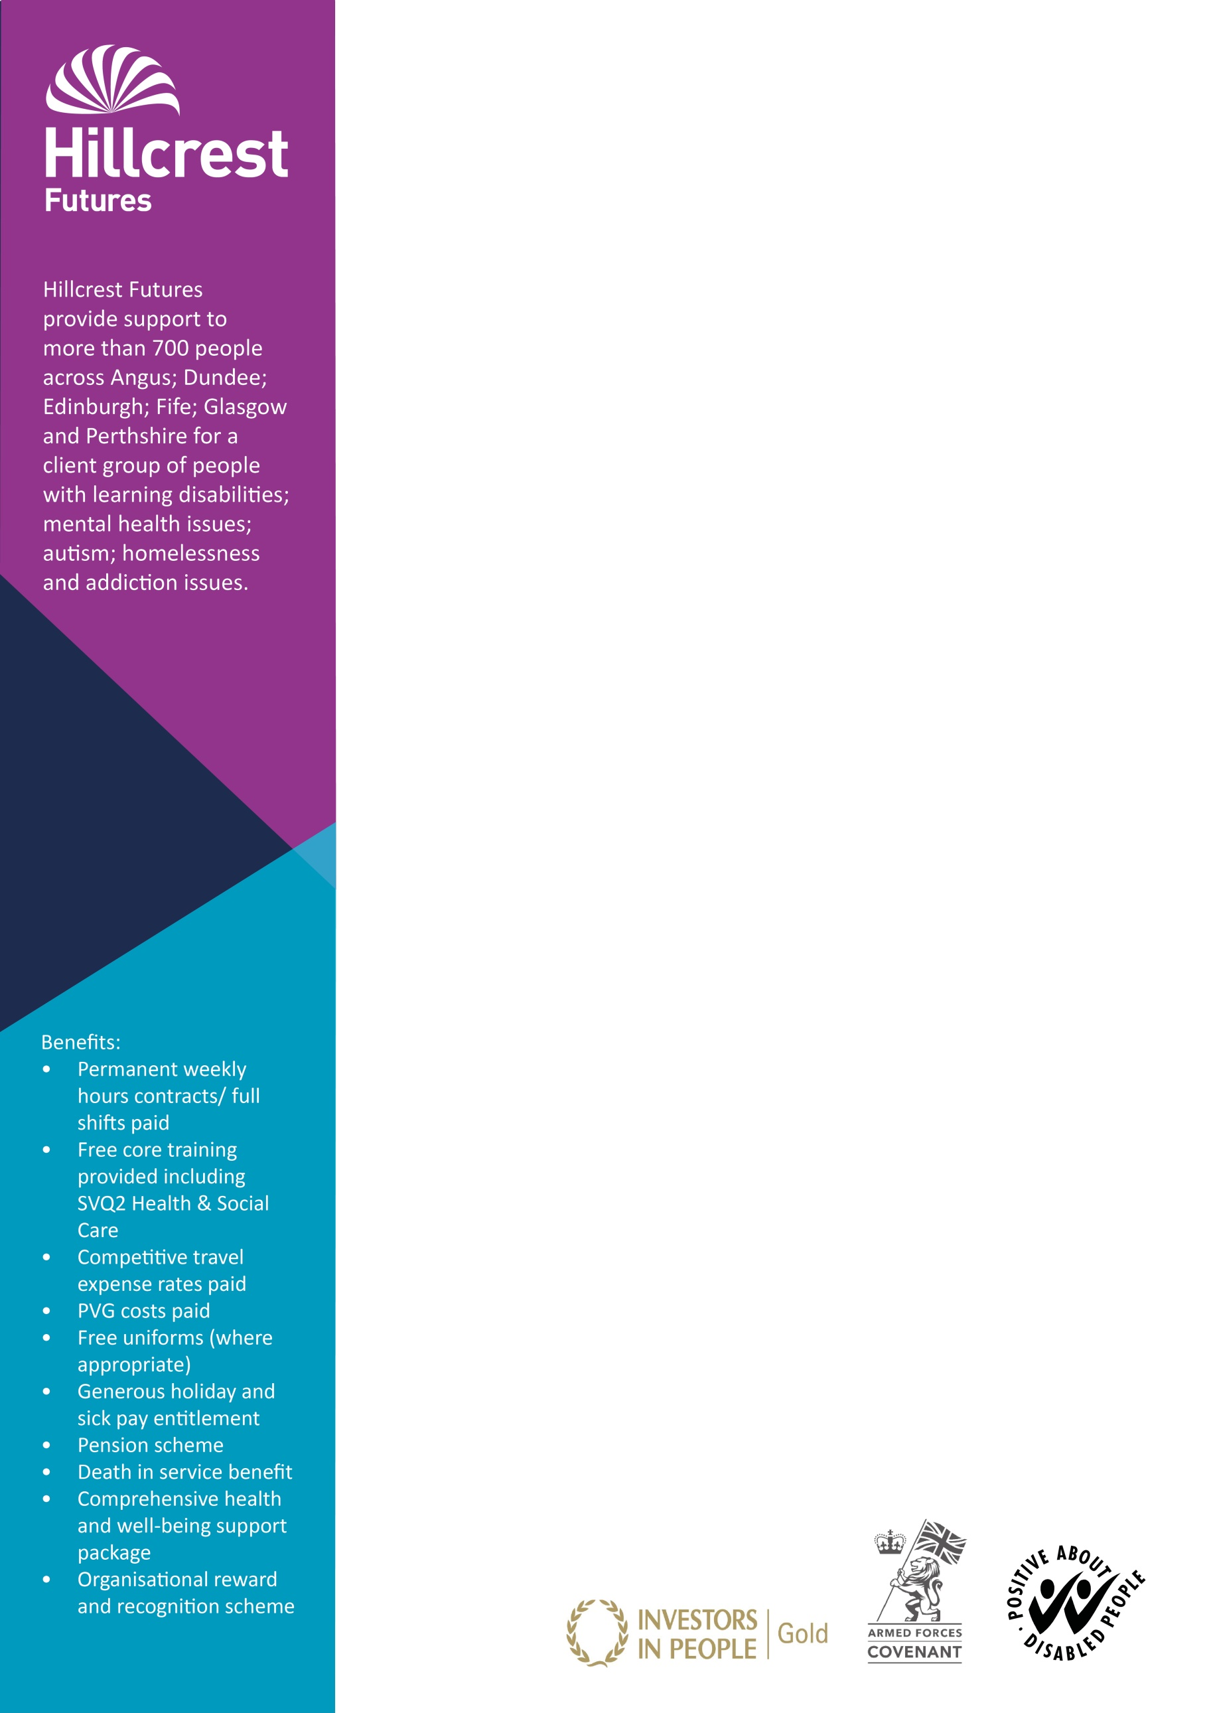

**The service**

Our Cupar Shared Living Accommodation provides housing support and care at home services to four individuals with learning disabilities.

**The job**

You will provide active support to enable individuals to achieve and manage their health and social care needs through a holistic and person centred approach.

**The candidate**

We would be keen to hear from you if you are:

* Positive, flexible and committed to making a difference
* Have or are willing to undertake an SVQ2 award
* Willing and able to work shifts, including sleepovers and weekend working

**Application process**

Applications can be made through our website:

[www.](http://www.)hillcrestfutures.org.uk

Job ref: HH19/128   
Post: Support Workers  
Location: Cupar (shared living accommodation)

Hours per week: Various part time and full time positions   
Rate of pay: £18,252 per annum (£9.00 per hour)  
Contract terms: Permanent

Closing date: Friday, 26th July 20198

**Please note we do not accept C.V’s or approaches from recruitment agencies.**

We promote equality through seeking to eliminate unlawful and unfair forms of discrimination, as appropriate.

Hillcrest Futures Ltd is a registered Charity No. SC034261

*V3Jul2019*