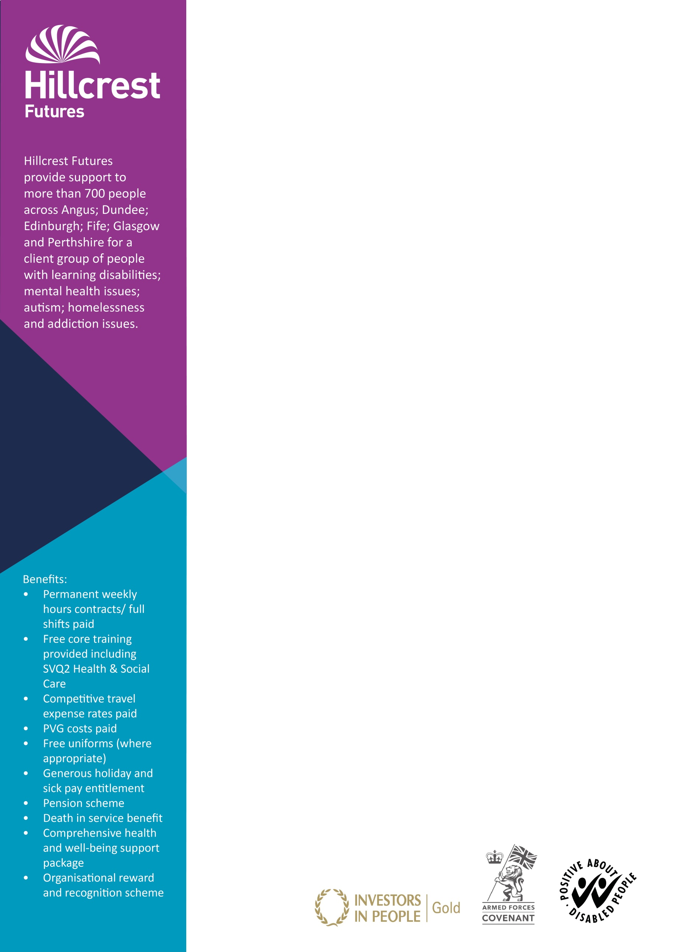

**The Services**

Our services are based at Dunfermline Outreach, Kinloss Park (Cupar) and Houston Court Outreach (Cupar)

Dumfermline Outreach operates 7 days a week between the hours of 7.30am and 10.30pm and Houstion Court operates 7 days oer week between the hours of 7.00am – 10.00pm.

The Service user needs cover a wide range including learning disability, complex needs, mental health and autism. The service users have their own tenancies and require support to keep their homes safe, secure and how they would like it.

Kinlos Park operates 24 hours per day, 7 days oer week. We support 4 people (3 male and 1 female) within their own home providing 24 hour support for adults with learning disabilities. Each individual has varying levels of support requirements and utilises a variety of external agencies.

**The Role**

* You will provide active support to enable individuals to achieve and manage their health and social care needs through a holistic and person centred approach.

**The Candidate**

* You should be positive, flexible and committed to making a difference
* Possess an SVQ 2 in Health & Social Care or have the willingness to work towards this qualification
* Be required to register with the Scottish Social Services Council (SSSC) within 6 months of taking up the post

**Application process**

Please apply on our website for this role at;  
  
[Hillcrest Futures Careers](https://careers.hillcrest.org.uk/hillcrest/search/results/feedid-5157_futuredays-0_-all_field7670-2/1)

Job ref: HH19/RSW - FIFE  
Post: Relief Support Worker   
Location: Fife

Hours per week: Relief – as and when required   
Rate of pay: £9.00 per hour  
Contract terms: Relief  
Closing date: 31st December 2019

*V3Jul2019*