

**ROLE PROFILE**

**Job Title:** Human Resource Advisor

**Department:** Corporate Services

**Band/Salary:** Band E - £35,832 - £40,217 per annum (Pay Award Pending 1st April 2025)  
  
(Salary is based on Full Time hours of 35.25 hours per week)

**Responsible to:** Senior HR Business Partner

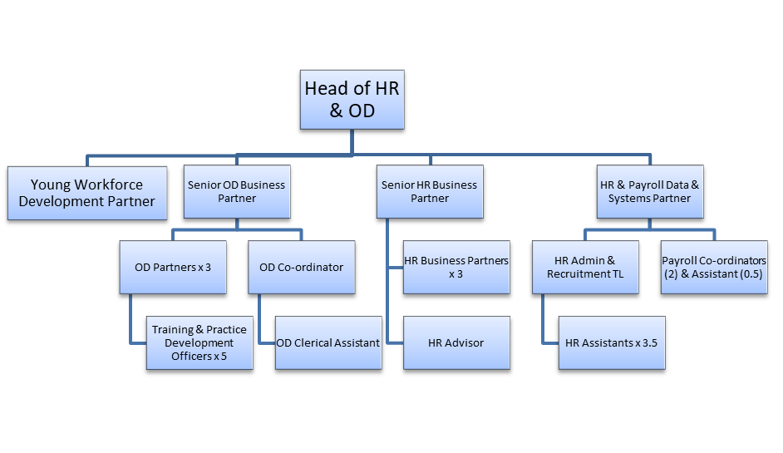

**Main Purpose of Post:**

To act as an adviser to managers and staff, providing effective, professional and proactive HR Solutions which enable teams and individuals to maximise their potential whilst being inclusive and supporting all to have a readiness for change.

**Main Duties and Responsibilities:**

* Support the business to attract, retain and develop talent whilst maintaining compliance to employment legislation and best practice and promoting equality, diversity and inclusion.
* Manage the effective and timely handling of employee relations case work (disciplinary, absence, grievances, performance, capability) with dignity and respect and implement initiatives to drive and maintain an overall culture of excellent employee relations and positive communication.
* Support the design and, or delivery of key people projects in line with the HR activity plan, organisational changes and improvement requirements with the aim of achieving alignment and effective communication of key HR priorities.
* Provide HR expertise to projects led by others.
* Support the delivery of training and development initiatives to support managers
* Interpret and produce high quality, accurate HR and workforce planning reports to identify people issues and trends within the business and work together with key stakeholders in order to formulate and implement solutions.
* Work in close collaboration with HR colleagues to enable and support efficient administration, effective use of IT systems
* Support the process of ensuring that all HR processes and procedures are robust, fit for purpose and comply with legislation as well as reviewing existing HR Policy, developing and supporting the implementation of new policies and processes, whilst supporting managers and staff in their application.
* Coach and advise line managers on the management of employee related issues within their team.
* Facilitating open and honest conversations at all levels balancing the needs of the business with the wider people strategy
* Ensure compliance with policies, procedures, together with all relevant regulatory & statutory requirements.
* Demonstrate commitment to our Values, Behaviours and your continuous personal development.
* Perform other reasonable duties and, or projects as directed by your line manager.



**Person Specification – Human Resource Advisor**

|  |  |  |  |
| --- | --- | --- | --- |
| **Attribute** | **Essential** | **Desirable** | **Method of Assessment** |
| **Qualifications** | * Educated to CIPD level 5 or SCQF level 8, HND or equivalent in related subject | * CIPD level 7 or SCQF level 11 | * Application Form * Qualification Certificate |
| **Experience** | * Strong technical and operational knowledge of HR activities from a generalist perspective (e.g. Employee Relations, Diversity and Inclusion, People Analytics) * A sound knowledge of employee relations and UK employment law and experience of applying this in practice * Experience of working with HR and Payroll systems * Skilled in the art of building and maintaining effective relationships at all levels with the ability to establish good rapport and credibility | * Demonstrable experience of working in a HR specific environment or role. * Evidence of continued professional development. * Experience of working with an Applicant Tracking System. | * Application Form * To evidence at Interview * References for verification |
| **Proven Competencies** | * Strong IT skills in the use of MS excel, word, access and outlook * Excellent MS Excel skills * Customer focussed, with an ability to build positive working relationships * High attention to detail, good organisation and time management skills * Ability to manage multiple priorities and a varied workload whilst working under pressure * Good communication skills both verbal and in writing * Excellent interpersonal skills * Ability to problem solve and use own initiative to resolve queries to a satisfactory conclusion * Be a champion for continuous improvement | * Advanced knowledge of MS Office software including Pivot Tables, IF statements and look up tables. | * Application Form * To evidence at Interview * References for verification * Test and, or Written Exercise |
| **Role Specific Requirements** | * Ability to deal with matters confidentially and sensitively * The ability to use judgement, problem solving skills and initiative to provide information and support and to recognise where issues may need to be referred onwards to be addressed by HR Business Partners * Hold a valid Driving Licence and have access to own car |  | * To evidence at Interview * References for verification |



**CONDITIONS OF SERVICE**

**Hours:** Hours are 30 hours per week. Where additional hours are worked, overtime will be paid (must exceed full time hours if part time) or time off in lieu given, depending on the organisational requirements. A flexi system is in operation.

**Contract:** Permanent Post. All posts are subject to a 6 month probationary period. A formal review will take place at 2, 4 and 6 months.

**Band and Salary:** This post is Band E.

Salaries are paid monthly, directly into a bank account of your choice. The salary for the post of HR Advisor is £30,495.31 - £34,227.23 per annum. (This has been pro rata for 30 hours) It is policy to commence on the first point of the salary scale unless, at the Manager’s discretion, an alternative agreement is reached.

**Pension:** Employees will initially be enrolled in the Governments statutory auto-enrolment scheme, which is a Defined Contribution scheme with a company called NOW Pensions. At present staff contribute 5% with the employer 3% to the scheme. Further details of the scheme are available from the payroll team.

Employees with a contract of 6 months or more can however opt out of the auto-enrolment scheme and request to join Hillcrest Homes Defined Contribution Scheme with the TPT Retirement Solutions where the employee currently contributes 8.5% of earnings and the Organisation’s contribution is 8.5%.

**Health Plan:** Employee’s are automatically given free admission to the Health Plan Scheme. The cost for this is met by the Employer. Details will be sent out with the Contract of Employment.

**Annual Leave: Leave year runs from 1st January - 31st December.** Annual Leave entitlement is 225.6 hours per annum (6.4 weeks), rising to 260.85 hours (7.4 weeks) over a 5 year period.

5 days public holidays have been included in this annual leave entitlement. Managers will commence on 260.85 hours. You are required to retain 35.25 hours annual leave (or part time equivalent) to cover the shutdown period over Christmas and New Year.

**Annual leave is calculated on a pro rata basis for part time staff.**

**General:** Hillcrest Homes have their own system in place for negotiating annual pay increases. All employees have the right to join a trade union if they so wish.

**Smoking:** The person appointed will be working in a non-smoking environment. There are no designated smoking areas within the office. Smoking is permitted outside the building and should be out of view of clients and, or customers. This includes the use of E-cigarettes. Employees who are required to carry out their duties in buildings which are outwith the control of the Association are jointly responsible for minimising their own exposure to risk factors such as passive smoking.

**Qualifications:** Any offer will be subject to proof of qualifications essential, and where appropriate desirable, to the post.

**Rehabilitation of** If you have any unspent convictions you must declare

**Offenders Act 1974:** this on your application form.

In relation to ‘spent’ convictions, there is a list of convictions which must always be declared and a list of convictions that are declared, subject to rules. Failure to disclose relevant information will be regarded as a breach of trust and could lead to dismissal, disciplinary action or withdrawal of offers of employment.

If you are unsure whether or not you need to disclose a conviction and, or caution, please contact our Human Resources Department for further advice, or you can check by accessing Disclosure Scotland’s website at [www.disclosurescotland.co.uk](http://www.disclosurescotland.co.uk/) and check the ‘Frequently Asked Questions’.

Please note that all successful applicants will be subject to a Disclosure check through Disclosure Scotland.

HAVING A CRIMINAL RECORD WILL NOT NECESSARILY DEBAR YOU FROM WORKING WITH HILLCREST HOMES. THIS WILL DEPEND ON THE NATURE OF THE POSITION, TOGETHER WITH THE CIRCUMSTANCES AND BACKGROUND OF YOUR OFFENCES.

**Equal Opportunities:** Hillcrest Homes is striving to be an equal opportunities employer and has adopted a Policy which aims to ensure that no job applicant receives less favourable treatment on grounds of race, colour, ethnic and national origins, marital status, gender, age, religion, disability, political or sexual orientations, or is disadvantaged by conditions or requirements which cannot be shown to be justifiable.

**Applications:** Please forward applications before the closing date**.**