

**ROLE PROFILE**

**Job Description**

**Job Title:** Organisational Development Partner

**Department:** Corporate Services

**Responsible to:** Senior Organisational Development Partner

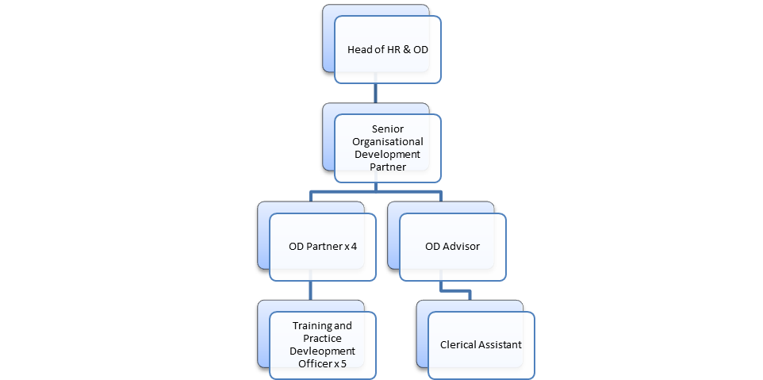

**Main Purpose of Post:**

This post holder will work with the Senior Organisational Development Partner to develop and deliver the operational plans and agreed actions for the team.

The Organisational Development Partner will support the delivery of the People & Organisational Development Strategy to contribute to the achievement of organisational goals and objectives. The post holder will review, analyse, monitor and evaluate data to drive organisational initiatives to achieve positive outcomes that will aid improvements in performance

* **Main Duties and Responsibilities:** Carry out training needs analysis for the workforce, identifying skills and behavioural gaps, implementing innovative solutions that align with individual and organisational needs.
* Conduct organisational assessments to identify strengths, weaknesses, areas for improvement and development opportunities.
* Design and implement organisational development programs, including continuous improvement, leadership development, succession planning, change management and wellbeing initiatives.
* Design and facilitate workshops, training sessions, and development initiatives to enhance organisational performance, employee engagement and personal development.
* Collaborate with managers and other support services to deliver change management initiatives.
* Analyse data and metrics to measure the effectiveness of organisational development programs and make data-driven recommendations for improvement.
* Provide support, advice and guidance to leaders and employees to enhance their professional growth and performance.
* Enhance the employee lifecycle experience through the continuous review and improvement of organisational initiatives.
* Promote our commitment to wellbeing and inclusivity by demonstrating our values and frameworks in the delivery of your duties.
* Support the Senior Organisational Development Partner in the on-going maintenance and improvement of systems and processes, policies and procedures.

* Work with relevant subject matter experts to develop Learning and Development resources which will meet the diverse needs of staff across Hillcrest.
* Support Hillcrests investment in people through the achievement of appropriate accreditations including Investors In People (IIP) and Investors in Young People (IIYP).
* Develop strong relationships with internal and external stakeholders and networks to support Hillcrests goals and objectives.
* Undertake relevant Continuous Professional Development to ensure you stay current on industry trends and best practices in organisational development and incorporate them into our strategies.
* Any other reasonable duties as required.



**Person Specification – Organisational Development Partner**

|  |  |  |  |
| --- | --- | --- | --- |
| **Attribute** | **Essential** | **Desirable** | **Method of Assessment** |
| **Qualifications** | * Qualified to SCQF level 8 in a relevant subject or equivalent experience in an Organisational Development role. * CIPD Level 5 Organisational Learning & Development | * Learning and Development 9D/DI or equivalent assessor award. * Learning and Development 11 or equivalent internal verifier award. | * Application Form * Qualification Certificate |
| **Experience** | * Previous experience of working in an organisational development environment. * Previous experience of working on change management activities. * Proficient in data analysis and the ability to use data to drive decision-making. * Knowledge of organisational development principles, methodologies, and best practices. * Previous experience of actively undertaking all aspects of the training cycle, including learning needs analysis, design, developing, delivering and evaluation. * Experience of Adult Learning and Development. * Experience of working with Learning Management Systems. | * Project Management experience. * Knowledge and understanding of succession planning processes. * Coaching and or Mentoring experience. * Experience of working in housing or care sector * Experience of eLearning packages. * Experience in dealing with funding applications. * Experience of designing reporting tools and visual dashboards using a variety of software | * Application Form * To evidence at Interview * References for verification |
| **Skills and abilities** | * Excellent interpersonal, communication, and presentation skills. * Ability to work collaboratively and influence stakeholders at all levels of the organisation. * Ability to prioritise workload to meet deadlines. * Excellent organisational and time management skills. * Strong facilitation skills. * Ability to competently utilise a broad range of software, including functions of MS Office 365. * Strong capability to design digital learning resources using a range of tools. * Creative and solution focused. * High standard of customer care and personal integrity. * Able to work independently and as part of a team | * Awareness of General Data Protection Regulations. * Creativity to promote user engagement. | * Application Form * To evidence at Interview * References for verification * Test and, or Written Exercise |
| **Role Specific Requirements** | * Driving licence. * Willingness to travel as required. * Willingness to undertake training as required. |  | * To evidence at Interview * References for verification |



**CONDITIONS OF SERVICE**

**Hours:** Hours are 35.25 hours per week. Where additional hours are worked, overtime will be paid (must exceed full time hours if part time) or time off in lieu given, depending on the organisational requirements. A flexi system is in operation.

**Contract:** Permanent Post. All posts are subject to a 6 month probationary period. A formal review will take place at 2, 4 and 6 months.

**Band and Salary:** This post is Band E.

Salaries are paid monthly, directly into a bank account of your choice. The salary for the post is £35,832 - £40,217 per annum. It is policy to commence on the first point of the salary scale unless, at the Manager’s discretion, an alternative agreement is reached.

**Pension:** Employees will initially be enrolled in the Governments statutory auto-enrolment scheme, which is a Defined Contribution scheme with a company called NOW Pensions. At present staff contribute 5% with the employer 3% to the scheme. Further details of the scheme are available from the payroll team.

Employees with a contract of 6 months or more can however opt out of the auto-enrolment scheme and request to join Hillcrest Homes Defined Contribution Scheme with the TPT Retirement Solutions where the employee currently contributes 8.5% of earnings and the Organisation’s contribution is 8.5%.

**Health Plan:** Employee’s are automatically given free admission to the Health Plan Scheme. The cost for this is met by the Employer. Details will be sent out with the Contract of Employment.

**Annual Leave: Leave year runs from 1st January - 31st December.** Annual Leave entitlement is 225.6 hours per annum (6.4 weeks), rising to 260.85 hours (7.4 weeks) over a 5 year period.

5 days public holidays have been included in this annual leave entitlement. Managers will commence on 260.85 hours. You are required to retain 35.25 hours annual leave (or part time equivalent) to cover the shutdown period over Christmas and New Year.

**Annual leave is calculated on a pro rata basis for part time staff.**

**General:** Hillcrest Homes have their own system in place for negotiating annual pay increases. All employees have the right to join a trade union if they so wish.

**Smoking:** The person appointed will be working in a non-smoking environment. There are no designated smoking areas within the office. Smoking is permitted outside the building and should be out of view of clients and, or customers. This includes the use of E-cigarettes. Employees who are required to carry out their duties in buildings which are outwith the control of the Association are jointly responsible for minimising their own exposure to risk factors such as passive smoking.

**Qualifications:** Any offer will be subject to proof of qualifications essential, and where appropriate desirable, to the post.

**Rehabilitation of** If you have any unspent convictions you must declare

**Offenders Act 1974:** this on your application form.

In relation to ‘spent’ convictions, there is a list of convictions which must always be declared and a list of convictions that are declared, subject to rules. Failure to disclose relevant information will be regarded as a breach of trust and could lead to dismissal, disciplinary action or withdrawal of offers of employment.

If you are unsure whether or not you need to disclose a conviction and, or caution, please contact our Human Resources Department for further advice, or you can check by accessing Disclosure Scotland’s website at [www.disclosurescotland.co.uk](http://www.disclosurescotland.co.uk/) and check the ‘Frequently Asked Questions’.

Please note that all successful applicants will be subject to a Disclosure check through Disclosure Scotland.

HAVING A CRIMINAL RECORD WILL NOT NECESSARILY DEBAR YOU FROM WORKING WITH HILLCREST HOMES. THIS WILL DEPEND ON THE NATURE OF THE POSITION, TOGETHER WITH THE CIRCUMSTANCES AND BACKGROUND OF YOUR OFFENCES.

**Equal Opportunities:** Hillcrest Homes is striving to be an equal opportunities employer and has adopted a Policy which aims to ensure that no job applicant receives less favourable treatment on grounds of race, colour, ethnic and national origins, marital status, gender, age, religion, disability, political or sexual orientations, or is disadvantaged by conditions or requirements which cannot be shown to be justifiable.

**Applications:** Please forward applications before the closing date**.**